METHODS OF INSTRUMENTAL ANALYSIS

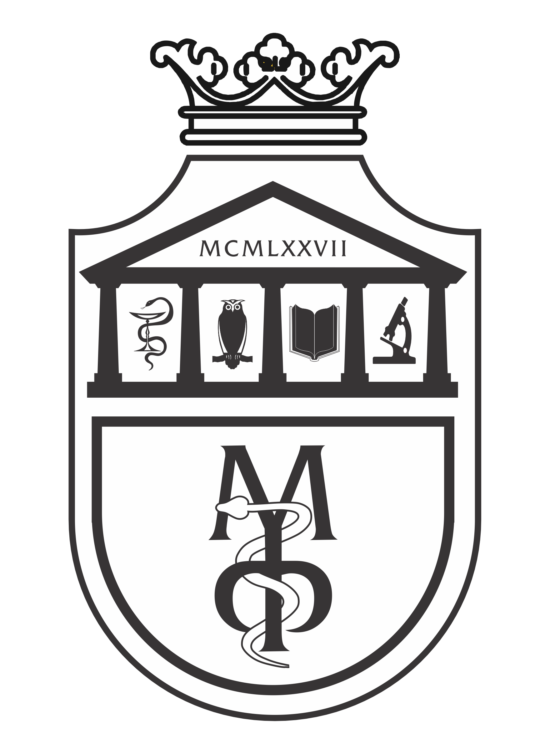

Pharmacy - Integrated academic studies

SECOND YEAR- Semester IV

2024/2025.

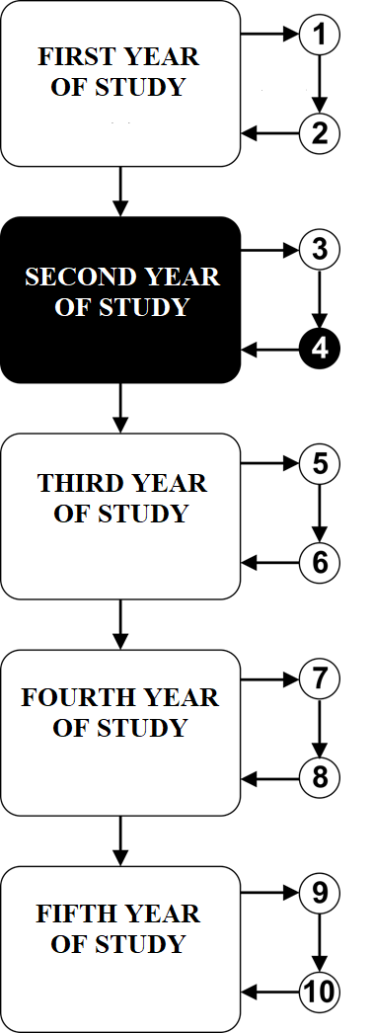

Subject:

METHODS OF INSTRUMENTAL ANALYSIS

The course is evaluated with 5 ECTS. The course consists of 4 hours of active classes per week (2
classes of lectures and 2 classes of small groups activity)

TEACHERS AND ASSOCIATES:

 | Name and surname | E-mail address | Academic rank
1. | Nedeljko Manojlović | mtnedeljko@yahoo.com | Full professor
2. | Jovica Tomović | jovicatomovic2011@gmail.com | Assistant professor

Course structure:
Module | Name of the module | Weeks | Lectures | Practice | Module Coordinator
1 | Principles and types of instrumental methods. Refractometry, polarimetry and colorimetry. Electrochemical methods. Potentiometry. pH-metry. Analysis of secondary metabolites. | 5 | 2 | 2 | Full prof. Nedeljko Manojlović
2 | Instrumental chromatographic methods. Gas and liquid chromatography. Combined methods. NMR spectroscopy. | 5 | 2 | 2 | Full prof. Nedeljko Manojlović
3 | UV-VIS and IR spectroscopy. Mass spectrometry. Solving spectral problems (UV-VIS and IR spectroscopy, NMR and MS). | 5 | 2 | 2 | Full prof. Nedeljko Manojlović
Σ 30+30=60

Students' knowledge assessment:

The student masters the subject by modules. The grade is equivalent to the number of points earned
(see tables). Points are earned in two ways:

ACTIVITY DURING THE LESSON: A student can earn a total of 30 points, 15 points during active participation in practical work and 15 points on the test that includes the material of the entire course (lectures, practices and spectral problems).
FINAL EXAM: In this way, a student can gain up to 70 points. Written exam includes the material of the entire course (lectures, practices and spectral problems).

MODULE |  | MAXIMUM POINTS
 |  | Exam prerequisites | Written examination | Σ
1 | Principles and types of instrumental methods. Refractometry, polarimetry and colorimetry. Electrochemical methods. Potentiometry. pH-metry. Analysis of secondary metabolites. | 5 | 70 | 100
2 | Instrumental chromatographic methods of analysis. Gas and liquid chromatography. Combined methods. NMR spectroscopy. | 5 | 70 | 100
3 | UV-VIS and IR spectroscopy. Mass spectrometry. Solving spectral problems (UV-VIS and IR spectroscopy, NMR and MS). | 5 | 70 | 100
 |  | 15
TEST |  | 15
Σ |  | 30 | 70 | 100

Number of acquired points | grade
0 – 50 | 5
51 – 60 | 6
61 – 70 | 7
71 – 80 | 8
81 – 90 | 9
91 – 100 | 10

LITERATURE:
Textbook | Authors | Publisher | Availability in the library
Pharmaceutical analysis: a textbook for pharmacy students and pharmaceutical chemists. | Watson DG. | Elsevier Health Sciences; 2015. | YES
Handbook of modern pharmaceutical analysis (Vol. 10). | Ahuja S. and Scypinski S. | Academic press; 2010. | YES
Pharmaceutical Analisys. | Lee D. | Oxford:Blackwell Scientific Publications. 2003. | YES
Ultraviolet and visible spetroscopy. | Thomas M. | New Jersay: John Willey and Sons. 1996. | YES
Atkins' Physical Chemistry , 11th Edition. | Atkins P, de Paula J, and Keeler J. | Oxford University Press. 2017. | YES

All lectures (powerpoint presentations) are available on the website of the Faculty of Medical science: www.medf.kg.ac.rs

PROGRAM

FIRST MODULE: PRINCIPLES AND TYPES OF INSTRUMENTAL METHODS. ATOMIC ABSORPTION SPECTROPHOTOMETRY, FLAME PHOTOMETRY, REFRACTOMETRY, POLARIMETRY AND COLORIMETRY. ELECTROCHEMICAL METHODS. POTENTIOMETRY. pH-METRY. ANALYSIS OF SECONDARY METABOLITES.

UNIT I (FIRST WEEK):

Lectures (2 classes) | Practice (2 classes)
Principles and types of instrumental methods. | Principles of instrumental methods.

UNIT II (SECOND WEEK):

Lectures (2 classes) | Practice (2 classes)
Electromagnetic radiation. Qualitative and quantitative analysis. Lambert-Beer law. | Methods for determining the qualitative and quantitative composition of pharmaceutical substances. Application of the Lambert-Behr law.

UNIT III (THIRD WEEK):

Lectures (2 classes) | Practice (2 classes)
Basics of refractometry, polarimetry and colorimetry. | Measurement on a refractometer, polarimeter and colorimeter.

UNIT IV (FOURTH WEEK):

Lectures (2 classes) | Practice (2 classes)
Electrochemical methods. Potentiometry. pH-metry. | Measurement on a pH-meter.

UNIT V (FIFTH WEEK):

Lectures (2 classes) | Practice (2 classes)
Analysis of natural products. | Extraction. Chromatographic analysis of plant extracts.

INSTRUMENTAL CHROMATOGRAPHIC METHODS OF ANALYSIS. GAS AND LIQUID CHROMATOGRAPHY. COMBINED METHODS. NMR SPECTROSCOPY.

UNIT VI (SIXTH WEEK):

Lectures (2 classes) | Practice (2 classes)
Instrumental chromatographic methods. Gas chromatography | Quantitative gas chromatographic analysis.

UNIT VII (SEVENTH WEEK):

Lectures (2 classes) | Practice (2 classes)
High Performance Liquid Chromatography-HPLC. | HPLC instrument.

UNIT VIII (EIGHT WEEK):
Lectures (2 classes) | Practice (2 classes)
Combined chromatographic spectroscopic methods. | Application of combined methods.

UNIT IX (NINTH WEEK):

Lectures (2 classes) | Practice (2 classes)
Basics of NMR spectroscopy. ¹ H NMR spectra. | Analysis of ¹ H NMR spectra.

UNIT X (TENTH WEEK):

Lectures (2 classes) | Practice (2 classes)
¹³C NMR and two-dimensional NMR spectroscopy. | Analysis of ¹³C NMR spectra.

THIRD MODULE: UV-VIS AND IR SPECTROSCOPY. MASS SPECTROMETRY.

UNIT XI (ELEVENTH WEEK):

Lectures (2 classes) | Practice (2 classes)
Basics of UV-VIS spectroscopy. UV-VIS spectra. Quantitative UV-VIS analysis. | Calculation of absorption maximum (λ_{max}).

UNIT XII (TWELFTH WEEK):

Lectures (2 classes) | Practice (2 classes)
Basics of IR spectroscopy. IR spectra. | Analysis of IR spectra.

UNIT XIII (THIRTEENTH WEEK):

Lectures (2 classes) | Practice (2 classes)
IR spectra of compounds with C=O group. Recording of IR spectra. | Analysis of IR spectra with carbonyl group and recording of spectra.

UNIT XIV (FOURTEENTH WEEK):

Lectures (2 classes) | Practice (2 classes)
Basics of mass spectrometry. Mass spectra. Analysis of mass spectra. | Fragmentation of molecules and analysis of mass spectra.

UNIT XV (FIFTEENTH WEEK):

Lectures (2 classes) | Practice (2 classes)
Solving spectral problems using chromatographic and instrumental methods (UV-VIS and IR spectroscopy, NMR and MS). | Spectral problems.

SCHEDULE OF LECTURES & PRACTICE

MONDAY
17.30-20.30
Hall at the
pediatric clinic

LESSON SCHEDULE FOR THE COURSE METHODS OF INSTRUMENTAL ANALYSIS

module | week | form | course unit title | teacher
1 | 1 | L | Principles and types of instrumental methods. | Prof. Dr. Nedeljko Manojlović
1 | 1 | P | Principles of instrumental methods. | Prof. Dr. Nedeljko Manojlović
1 | 2 | L | Electromagnetic radiation. Qualitative and quantitative analysis. Lambert-Beer law. | Prof. Dr. Nedeljko Manojlović
1 | 2 | P | Methods for determining the qualitative and quantitative composition of pharmaceutical substances. Application of the Lambert-Beer law. | Prof. Dr. Nedeljko Manojlović
1 | 3 | L | Basics of refractometry, polarimetry and colorimetry. | Prof. Dr. Nedeljko Manojlović
1 | 3 | P | Measurement on a refractometer, polarimeter and colorimeter. | Asst. Prof. Jovica Tomović
1 | 4 | L | Electrochemical methods. Potentiometry. | Prof. Dr. Nedeljko Manojlović
1 | 4 | P | Measurement on a pH-meter. | Asst. Prof. Jovica Tomović
1 | 5 | L | Analysis of natural products. | Prof. Dr. Nedeljko Manojlović
1 | 5 | P | Extraction. Chromatographic analysis of plant extracts. | Asst. Prof. Jovica Tomović
2 | 6 | L | Instrumental chromatographic methods. Gas chromatography | Prof. Dr. Nedeljko Manojlović
2 | 6 | P | Quantitative gas chromatographic analysis. | Prof. Dr. Nedeljko Manojlović
2 | 7 | L | High Performance Liquid Chromatography-HPLC. | Prof. Dr. Nedeljko Manojlović
2 | 7 | P | HPLC instrument. | Prof. Dr. Nedeljko Manojlović
2 | 8 | L | Combined chromatographic spectroscopic methods. | Prof. Dr. Nedeljko Manojlović
2 | 8 | P | Application of combined methods. | Prof. Dr. Nedeljko Manojlović
2 | 9 | L | Basics of NMR spectroscopy. ¹ H NMR spectra. | Prof. Dr. Nedeljko Manojlović
2 | 9 | P | Analysis of ¹ H NMR spectra. | Prof. Dr. Nedeljko Manojlović
2 | 10 | L | ¹³C NMR and two-dimensional NMR spectroscopy. | Prof. Dr. Nedeljko Manojlović
2 | 10 | P | Analysis of ¹³C NMR spectra. | Prof. Dr. Nedeljko Manojlović
3 | 11 | L | Basics of UV-VIS spectroscopy. UV-VIS spectra. Quantitative UV-VIS analysis. | Prof. Dr. Nedeljko Manojlović
3 | 11 | P | Calculation of absorption maximum (λ_{max}). | Prof. Dr. Nedeljko Manojlović
3 | 12 | L | Basics of IR spectroscopy. IR spectra. | Prof. Dr. Nedeljko Manojlović
3 | 12 | P | Analysis of IR spectra. | Prof. Dr. Nedeljko Manojlović
3 | 13 | L | IR spectra of compounds with C=O group. Recording of IR spectra. | Prof. Dr. Nedeljko Manojlović
3 | 13 | P | Analysis of IR spectra with carbonyl group and recording of spectra. | Prof. Dr. Nedeljko Manojlović
3 | 14 | L | Basics of mass spectrometry. Mass spectra. Analysis of mass spectra. | Prof. Dr. Nedeljko Manojlović
3 | 14 | P | Fragmentation of molecules and analysis of mass spectra. | Prof. Dr. Nedeljko Manojlović
3 | 15 | L | Solving spectral problems using chromatographic and instrumental methods (UV-VIS and IR spectroscopy, NMR and MS). | Prof. Dr. Nedeljko Manojlović
3 | 15 | P | Spectral problems. | Prof. Dr. Nedeljko Manojlović
 |  |  | FINAL TEST
 |  |  | EXAM

